**Tech Saksham**



Case Study Report

Data Analytics with Power BI

**“360-degree Business Analysis of Online Delivery Apps”**

**“Manonmaniam Sundaranar University College”**

|  |  |
| --- | --- |
| **NM ID** | **NAME** |
| 326A1F34C2D9D7094D941613FB381FBB | AAKASH S |

|  |  |
| --- | --- |
|  |  |
|  | **Trainer Name**: R UMAMAHESWARI |
|  | **Master Trainer**: R UMAMAHESWARI |

**ABSTRACT**

In the digital age, data has become an invaluable asset for businesses, particularly in the Online delivery apps. The proposed project, “360-degree Business Analysis of Online Delivery Apps using Power BI,” aims to leverage Power BI, a leading business intelligence tool, to analyze and visualize real-time customer data. This project will enable the owners of delivery apps to gain deep insights into customer behavior, preferences, and trends by reviews and ratings of various restaurants, thereby facilitating data-driven decision-making and enhancing customer satisfaction. The real-time analysis will allow delivery apps to respond promptly to changes in customer behavior or preferences, identify opportunities for cross-selling and up-selling, and tailor their products and services to meet customer needs. The project will also contribute to the broader goal of digital transformation in the online delivery platform, promoting efficiency, innovation, and customer-centricity.

**INDEX**

|  |  |  |
| --- | --- | --- |
| **Sr. No.** | **Table of Contents** | **Page No.** |
| 1 | Chapter 1: Introduction | 4 |
| 2 | Chapter 2: Services and Tools Required | 6 |
| 3 | Chapter 3: Project Architecture | 7 |
| 4 | Chapter 4: Modeling and Result | 9 |
| 5 | Conclusion | 18 |
| 6 | Future Scope | 19 |
| 7 | References | 20 |
| 8 | Links | 21 |

**CHAPTER 1**

**INTRODUCTION**

* 1. **Problem Statement**

In today’s upgraded world the online delivery apps becomes so popular, the volume of data keeps rising and data technologies change every other day, understanding customer behavior and preferences is crucial for customer retention and revenue generation. However, delivery apps often face challenges in analyzing customer data due to the sheer volume and velocity of data generated. Traditional data analysis methods are time-consuming and often fail to provide real-time insights. This lack of real-time analysis can lead to missed opportunities for customer engagement, cross-selling, and up-selling, impacting the revenue generation and customer satisfaction. Furthermore, the complexity and diversity of customer data, which includes ordered history, customer feedback, and demographic data, pose additional challenges for data analysis.

* 1. **Proposed Solution**

The proposed solution is to develop a Power BI dashboard that can analyze and visualize real-time customer data. The dashboard will integrate data from various sources such as order history, customer feedback, and demographic data. It will provide a comprehensive view of customer behavior, preferences, and trends, enabling delivery apps to make informed decisions. The dashboard will be interactive, user-friendly, and customizable, allowing users to tailor it to their specific needs. The real-time analysis capability of the dashboard will enable delivery apps to respond promptly to changes in customer behavior or preferences, identify opportunities for cross-selling and up-selling, and tailor their products and services to meet customer needs.

* 1. **Feature**
* **Real-Time Analysis**: The dashboard will provide real-time analysis of customer data.
* **Customer Segmentation**: It will segment customers based on various parameters like country, state, city, ratings, etc.
* **Trend Analysis**: The dashboard will identify and display trends in customer behavior.
* **Predictive Analysis**: It will use historical data to predict future customer behavior.
  1. **Advantages**
* **Data-Driven Decisions**: delivery apps can make informed decisions based on real-time data analysis.
* **Improved Customer Engagement**: Understanding customer behavior and trends can help delivery apps to engage with their customers more effectively.
* **Increased Revenue**: By identifying opportunities for cross-selling and up-selling, restaurants can increase their revenue through online delivery apps.
  1. **Scope**

The scope of this project extends to the delivery apps that aim to leverage data for decision-making and customer engagement. The project can be further extended to incorporate more data sources and advanced analytics techniques, such as machine learning and artificial intelligence, to provide more sophisticated insights into customer behavior. The project also has the potential to be adapted for other sectors, such as retail, healthcare, and telecommunications, where understanding customer behavior is crucial. Furthermore, the project contributes to the broader goal of digital transformation in the online delivery apps, promoting efficiency, innovation, and customer-centricity.

**CHAPTER 2**

**SERVICES AND TOOLS REQUIRED**

**2.1 Services Used**

* **Data Collection and Storage Services**: Delivery apps need to collect and store customer data in real-time. This could be achieved through services like Azure Data Factory, Azure Event Hubs, or AWS Kinesis for real-time data collection, and Azure SQL Database or AWS RDS for data storage. Currently the data is stored in the form of excel files.
* **Data Processing Services**: Power BI in Data Analytics can be used to process the real-time data, which mean user can view up-to-date data in their dashboard and reports.
* **Machine Learning Services**: Azure Machine Learning or AWS Sage Maker can be used to build predictive models based on historical data.

**2.2 Tools and Software used**

**Tools**:

* **Power BI**: The main tool for this project is Power BI, which will be used to create interactive dashboards for real-time data visualization.
* **Power Query**: This is a data connection technology that enables you to discover, connect, combine, and refine data across a wide variety of sources.

**Software Requirements**:

* **Power BI Desktop**: This is a Windows application that you can use to create reports and publish them to Power BI.
* **Power BI Service**: This is an online SaaS (Software as a Service) service that you use to publish reports, create new dashboards, and share insights.
* **Power BI Mobile**: This is a mobile application that you can use to access your reports and dashboards on the go.

**CHAPTER 3**

**PROJECT ARCHITECTURE**

**3.1 Architecture**

**USER FRONTEND BACKEND**

|  |  |  |
| --- | --- | --- |
|  | **Power BI**  Power BI Logo, symbol, meaning, history, PNG, brand | **Power Query**  **Leveraging Benefit of Power Query Editor List Functions in Power BI**  **Database** |

Here’s a high-level architecture for the project:

1. **Data Collection**: Real-time customer data is collected from various sources like food orders, restaurant reviews, customer interactions, etc. This could be achieved using services like Azure Event Hubs or AWS Kinesis.
2. **Data Storage**: The collected data is stored in a database for processing. Azure SQL Database or AWS RDS and excel files can be used for this purpose.
3. **Data Processing**: The stored data is processed in real-time using services like Azure Stream Analytics or AWS Kinesis Data Analytics and Power BI.
4. **Machine Learning**: Predictive models are built based on processed data using Azure Machine Learning or AWS Sage Maker. These models can help in predicting customer behavior, reviews of restaurant, etc.
5. **Data Visualization**: The processed data and the results from the predictive models are visualized in real-time using Power BI. Power BI allows you to create interactive dashboards that can provide valuable insights into the data.

**Data Access**: The dashboards created in Power BI can be accessed through Power BI Desktop, Power BI Service (online), and Power BI Mobile.

This architecture provides a comprehensive solution for real-time analysis of online delivery app customers. However, it’s important to note that the specific architecture may vary depending on the app infrastructure, specific requirements, and budget. It’s also important to ensure that all tools and services comply with relevant data privacy and security regulations.

**CHAPTER 4**

**MODELING AND RESULT**

**Manage relationship**

The “KPI’s” file will be used as the main connector as it contains most restaurant id, which can be used to relates the 6 data files together. Here the rest of the 6 tables which represent continent are merger into a single table called Zomato Global.

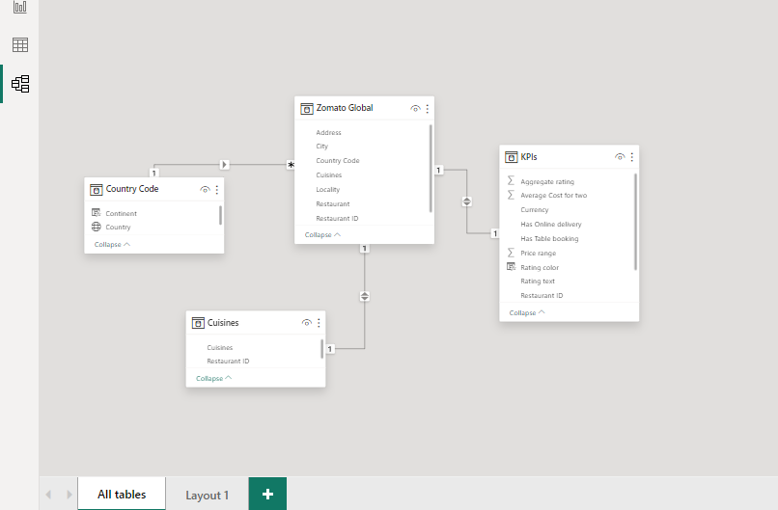

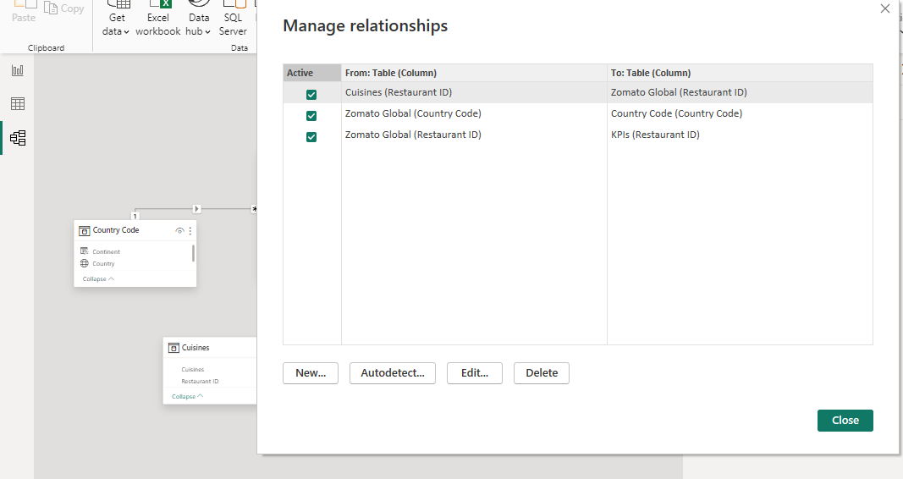

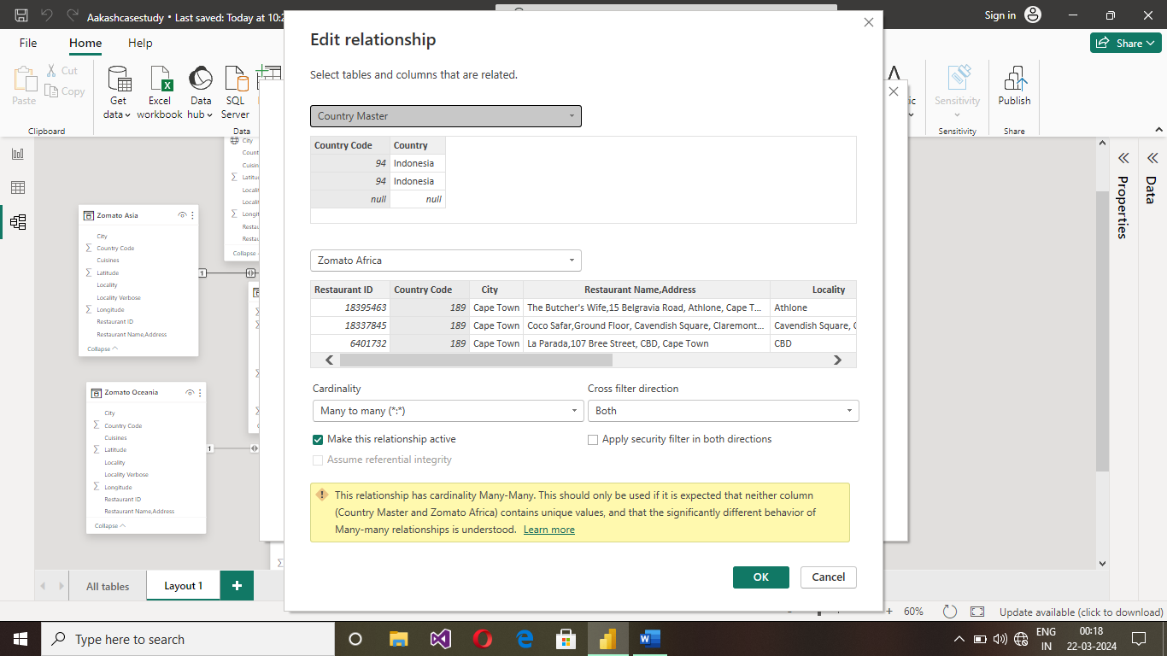

**Transformed the data**

Notice that the country name and code have null values. These values can be removed from the field by unselect the null value option and the Duplicates have been removed by selecting the remove duplicate.

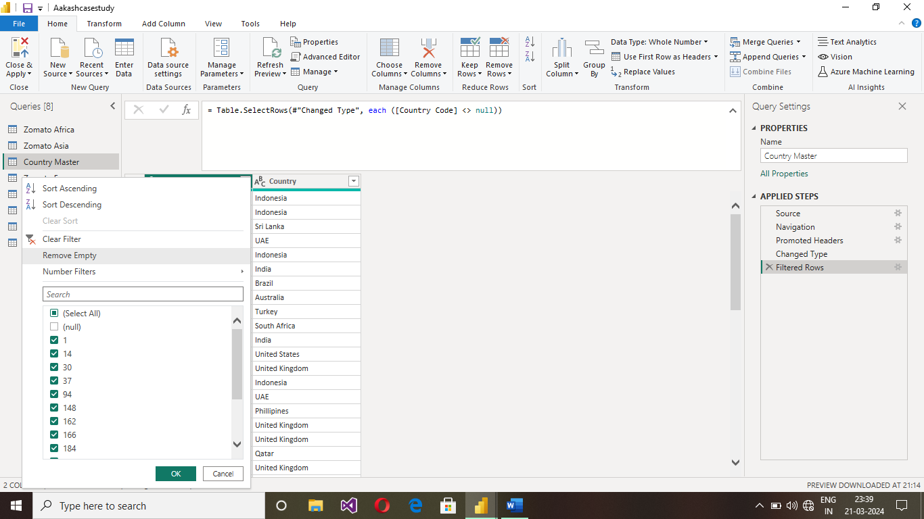

**Column Added**

In countryTablea new continent column is added to identify the country with their appropriate continent**.** It is accomplished by using power query with their unique country code.

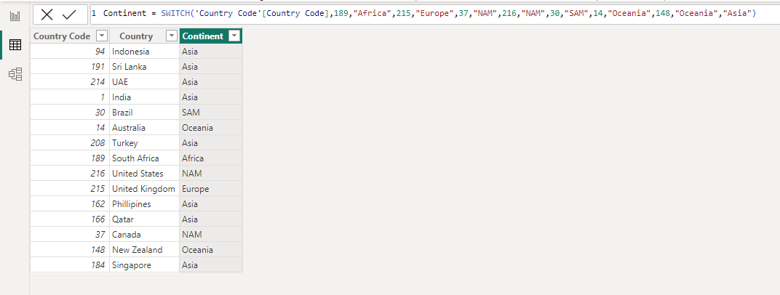

**Creating a New Table**

To identify the cuisines and the count of cuisines a separate table is created. The cuisine count is calculated using the new measure option.

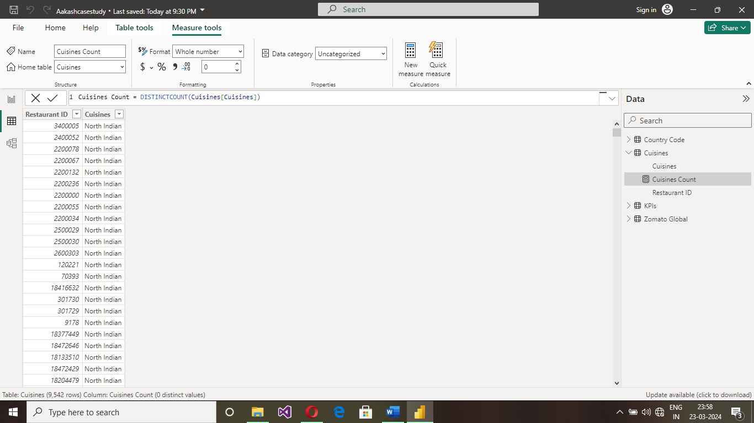

The restaurant ratings can be calculated and the rating can be separated by colors for that a new column named rating color is added to the KPI’s Table.

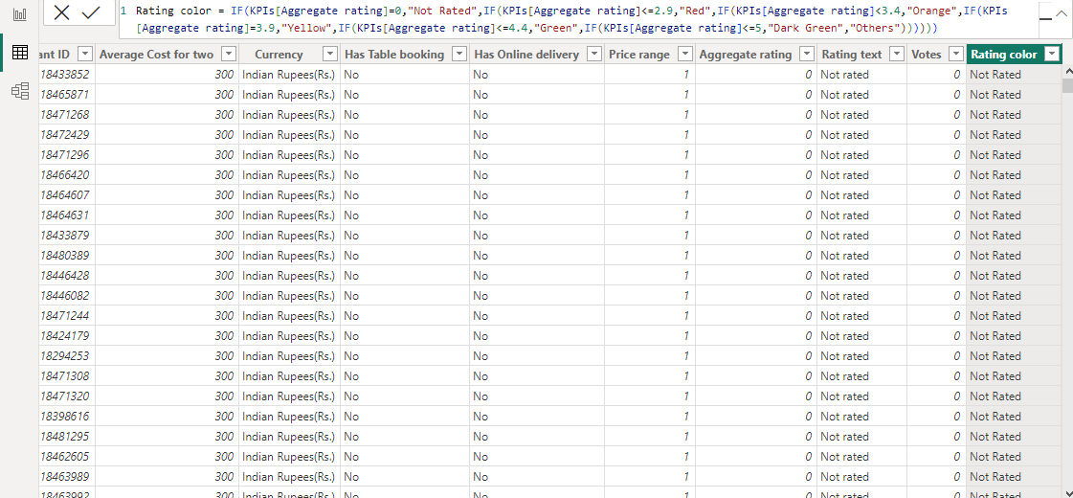

.

**Zomato Global**

The Zomato Global table is created from each continent table by using the append mode. After creating the global table, the restaurant name and address are separated by using the delimiter.

**Dashboard**

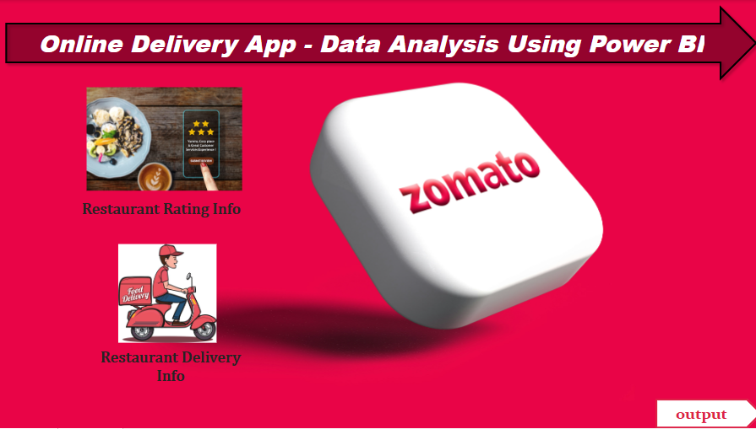

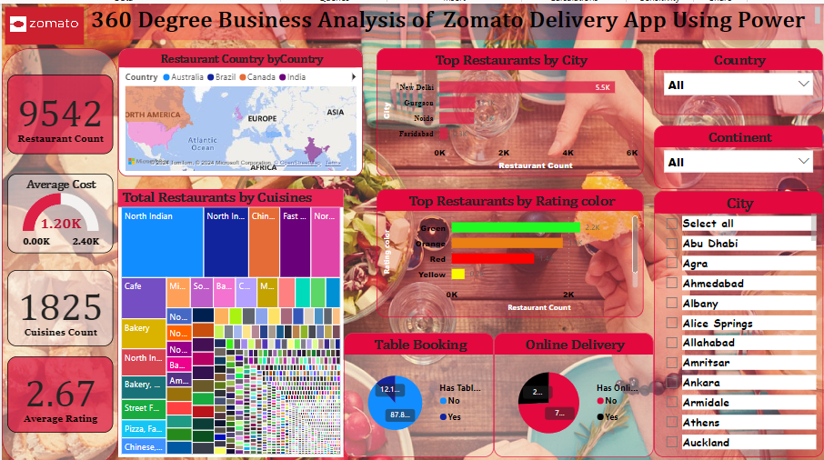

**CONCLUSION**

The project “360- degree Analysis of online delivery app” using Power BI has successfully demonstrated the potential of data analytics in the online delivery system. The real-time analysis of customer data has provided valuable insights into customer behavior, preferences, and trends, thereby facilitating informed decision-making. The interactive dashboards and reports have offered a comprehensive view of customer data, enabling the identification of patterns and correlations. This has not only improved the efficiency of data analysis but also enhanced the bank’s ability to provide personalized services to its customers. The project has also highlighted the importance of data visualization in making complex data more understandable and accessible. The use of Power BI has made it possible to present data in a visually appealing and easy-to-understand format, thereby aiding in better decision-making.

**FUTURE SCOPE**

The future scope of this project is vast. With the advent of advanced analytics and machine learning, Power BI can be leveraged to predict future trends based on historical data. Integrating these predictive analytics into the project could enable the delivery apps to anticipate customer needs and proactively offer solutions. Furthermore, Power BI’s capability to integrate with various data sources opens up the possibility of incorporating more diverse datasets for a more holistic view of customers. As data privacy and security become increasingly important, future iterations of this project should focus on implementing robust data governance strategies. This would ensure the secure handling of sensitive customer data while complying with data protection regulations. Additionally, the project could explore the integration of real-time data streams to provide even more timely and relevant insights. This could potentially transform the way restaurants and delivery apps interact with their customers, leading to improved customer satisfaction and loyalty.

**REFERENCES**

<https://medium.com/@ranganathan223/zomato-bangalore-restaurant-analysis-using-power-bi-397fce15f030>

<https://www.novypro.com/project/zomato-food-delivery-app---data-analysis>

Source Of Image: Google

**LINK**

<https://github.com/githubtraining/hellogitworld.git>